1) Write a SQL code to join two tables using the WHERE statement. Explain what the query is intended to do.

-> To display all the information from both Doctor and Appointment tables where the Doctor_ID matches by joining both tables using WHERE condition.

2) Repeat problem 1 using the JOIN … USING keywords.

-> Query performs the same function as the first question, but by showing all columns from both joined tables where Doctor_ID is the same.

3) Repeat problem 1 using the JOIN … ON keywords.

->Query displays all information from both Doctor and Appointment tables, by using the JOIN … ON keyword.

4) Repeat problem 1 but add at least two conditions in the WHERE statement and use an arithmetic and a special operator. Use logical operators to combine multiple conditions. Explain what the query is intended to do.

->Query retrieves all fields from the Doctor and Appointment table where Doctor_ID is the same, the Billing_Number is greater than 3000, and the doctor's name starts with "Dr.".

5) Repeat problem 2 but add two more conditions in the WHERE statement and use an arithmetic and a special operator that are different from the ones you used in the previous query. Use logical operators to combine multiple conditions. Explain what the query is intended to do

->This query adds conditions that is, Billing_Number must be less than 3005, and the doctor's address must not contain "Blod".

6-9) Repeat problems 1-4 above to join three tables.

I have joined the tables using the WHERE statement, USING keyword, ON keywords and WHERE with multiple conditions.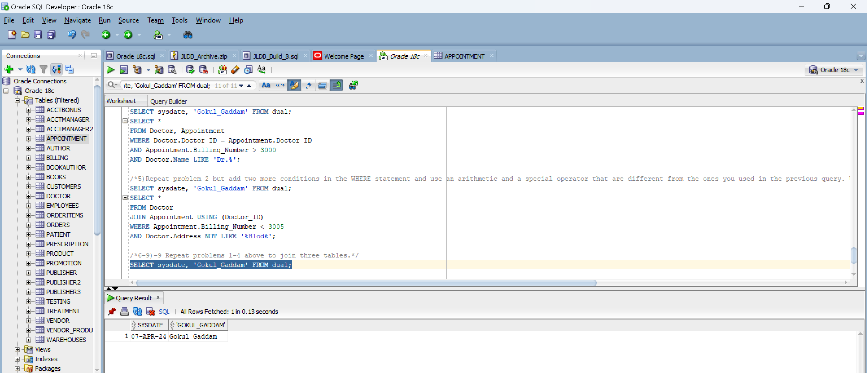

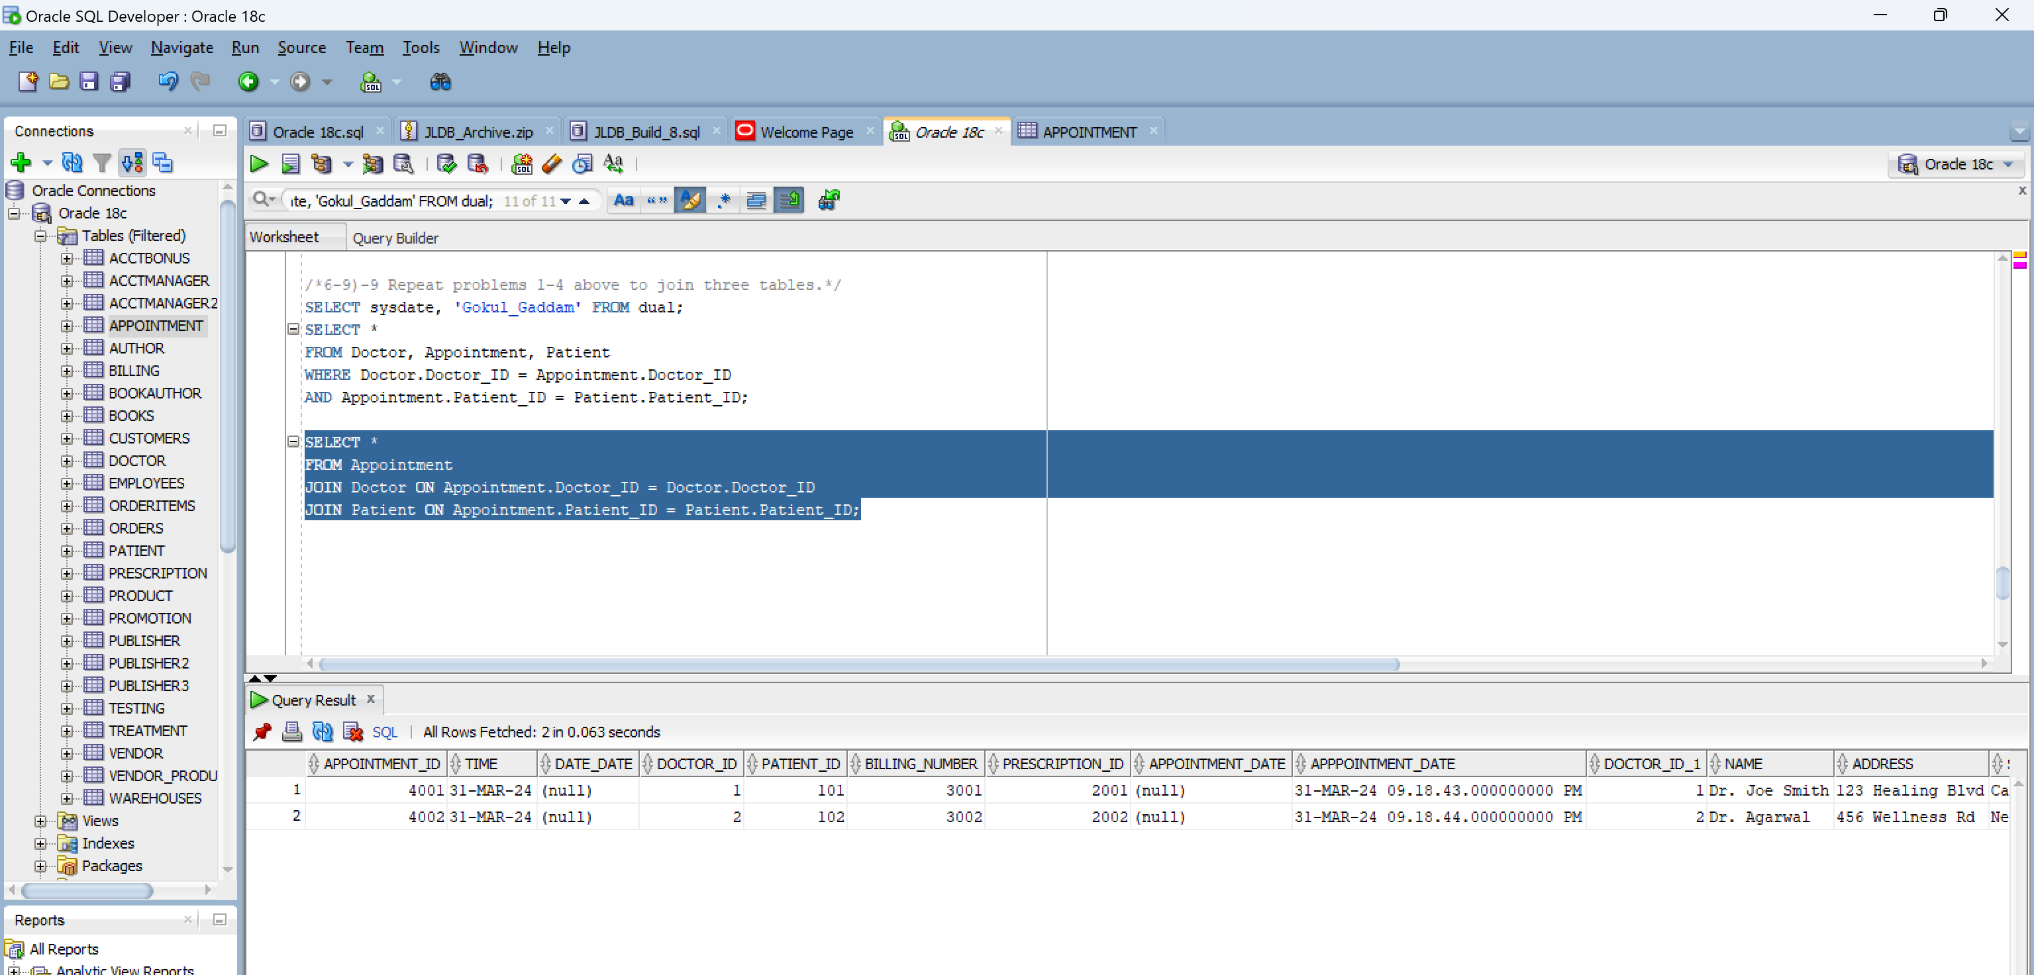

10) Write a SQL query that joins four tables using any type of join and uses both an arithmetic and special operator. Explain what the query is intended to do

The query finds records where the patient's address ends in "St." and the billing amount increased by 10% is at least $200. It joins four tables. Its goal is to locate particular appointments under certain cost and geographic constraints.

